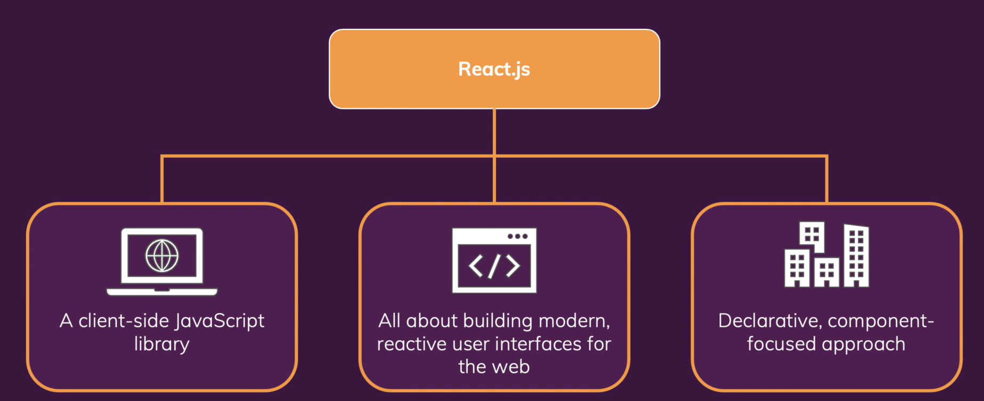

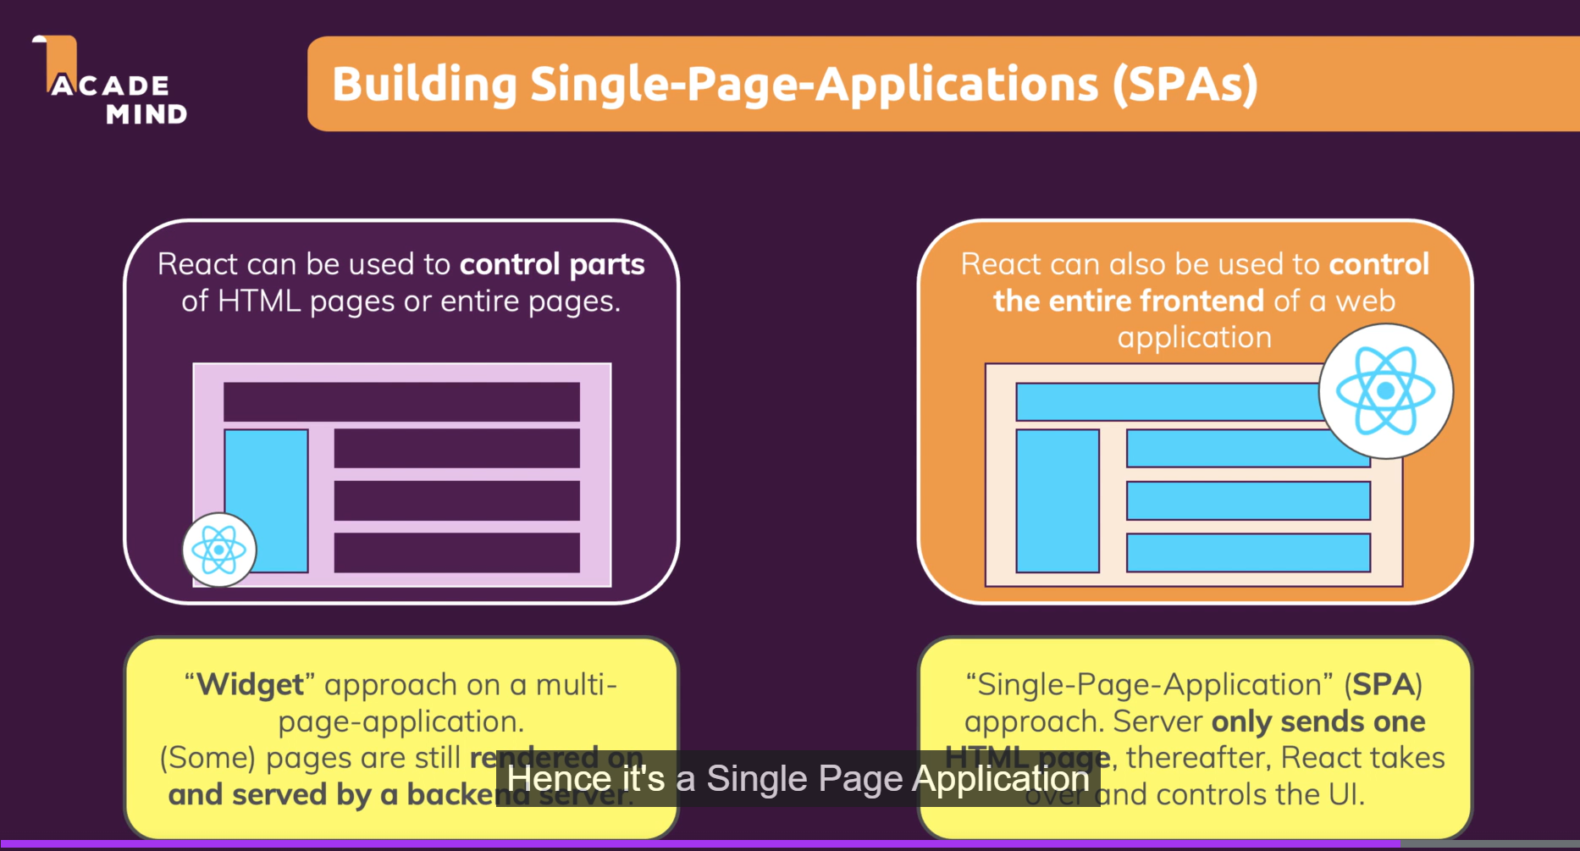

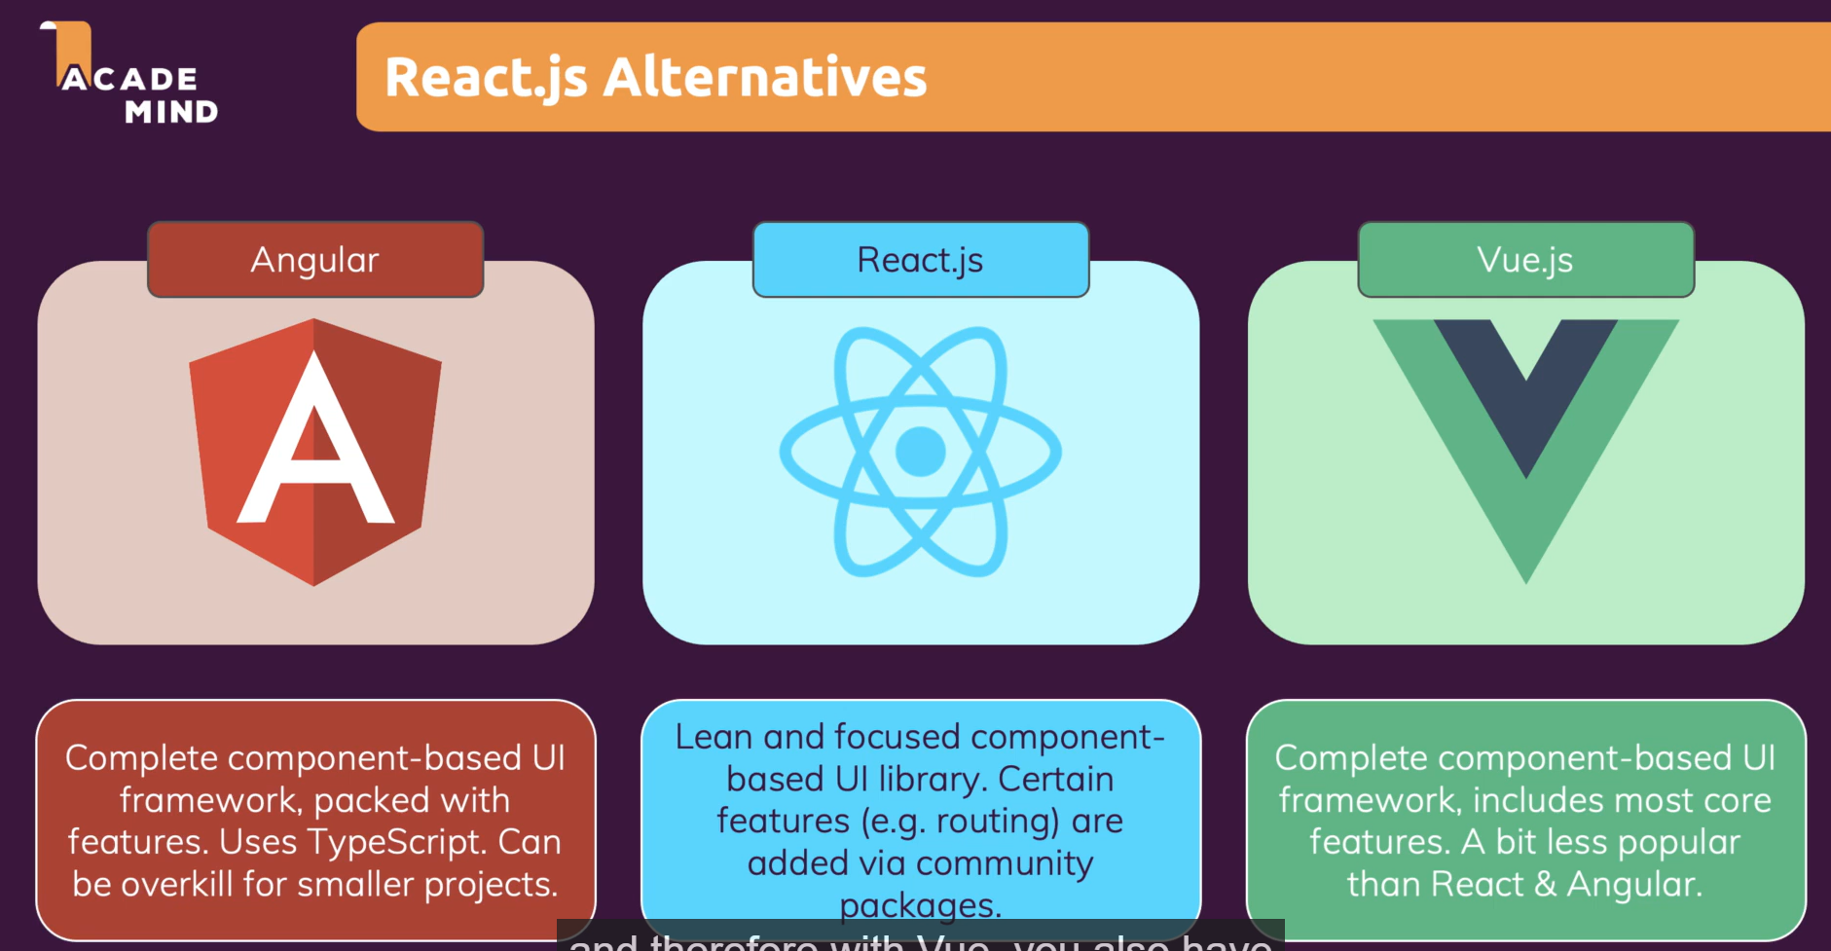

**Key Points:**

* React js is one of the most popular JavaScript front end library.
* It is declarative, efficient, and flexible JS library. It is open source.

**Why React js?**

* The main objective of ReactJS is to develop User Interfaces (UI) that improves speed of the apps.
* Today, most of the websites are built using MVC (model view controller) architecture.
* In MVC architecture, React is the 'V' which stands for view, whereas the architecture is provided by the Redux or Flux.

**Why learn React js?**

* Today, many JavaScript frameworks are available (like angular, node) but still, React gained popularity amongst them.
* The previous framework followed the traditional data flow structure, which uses DOM (Document object model).
* DOM is an object which is created by the browser each time web page is loaded.
* It dynamically adds or removes data in the backend whenever modifications done, ach time new DOM is created for same page.
* This led to unnecessary memory wastage & reduces the performance of the application.
* Thus, React came into picture to overcome this drawback. React allows to divide entire application into various components.
* It still uses same traditional data flow, but it won't directly operates on browser DOM, instead operates on virtual DOM.
* Due to this, when we write a React component, we did not write directly to the DOM; instead,
* We are writing virtual components that react will turn into the DOM.
* So, functions in React that start with use are considered React Hooks.

**The important features of ReactJS are as following.**

* JSX
* Components
* One-way Data Binding
* Virtual DOM
* Simplicity
* Performance

**AngularJs VS ReactJs**

|  |  |  |
| --- | --- | --- |
|  | **AngularJS** | **ReactJS** |
| ***Author*** | Google | Facebook Community |
| ***Developer*** | Misko Hevery | Jordan Walke |
| ***Initial Release*** | October 2010 | March 2013 |
| ***Latest Version*** | Angular 1.7.8 on 11 March 2019. | React 16.8.6 on 27 March 2019 |
| ***Language*** | JavaScript, HTML | JSX |
| ***Type*** | Open Source MVC Framework | Open-Source JS Framework |
| ***Rendering*** | Client-Side | Server-Side |
| ***Data binding*** | Bi-directional | Uni-directional |
| ***DOM*** | Regular DOM | Virtual DOM |
| ***Testing*** | Unit and Integration Testing | Unit Testing |
| ***Performance*** | Slow | Fast, due to virtual DOM. |
| ***Best For*** | It is best for single page applications that update a single view at a time. | It is best for single page applications that update multiple views at a time. |